** Design Document Guideline**

**Apartment System**

Version 1.1

Prepare by

Narawit Kaewbun

31/October/2016

**1.Revision History**

**2.Use Case Overview**

**Use Case Diagram Level 0 : Management System**

Management Sub - System

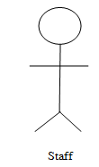

**Use Case Diagram Level 1 : Customer Management System**

Customer Management Sub - System

Staff